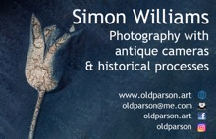
Photography Workshops Offer
2022

During 2022, I am offering a range of activities and workshops to Camera Clubs, Photographic Societies, Arts organisations and to the public at venues in Weston, Clevedon and Cheddar

“Through an older eye – the workshop”
Learn how to make new images in old “charity-shop” cameras. Cameras will be provided but participants can bring their own.

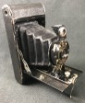
Using single pieces of film participants will create new images in old cameras
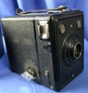
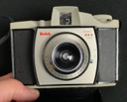
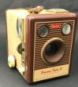

- We will learn how the cameras work – Lens, Film loading, Viewfinder, Shutter
- Using pre-cut pieces of sheet film (X-ray film) we will load the cameras under red-light conditions (Portable darkroom provided)
- The film negative will be unloaded and developed under red lights
- The negative will be inspected against a light table and viewed and recorded as a positive using The Kodak film scanner app.
- Participants will have time to try making 2 or 3 better/different images.
- The negatives can be saved for use in a follow-up workshop “Historic & Creative Photoprinting”.

Mental Health and Wellbeing
Reviving something that has been written off as outdated/useless is not only satisfying but speaks positively to the soul. Finding out how the cameras and wet photography work is stimulating learning and I hope will initiate further activity and interest after the workshop.

Workshop Structure – length of workshop 2 Hours
15 mins Arrivals and introductions and safety briefing (chemicals, trip hazards)
15 mins look at the cameras – learn how they work
10 mins practice loading and unloading pieces of film
10 mins – teaching on film speed and shutter speed options
10 mins teaching on measuring light levels with a phone app
15 mins to take the first image – set up/choose subject measure light
15 mins to unload film and develop it.
30 mins to make more and better pictures

Workshop Dates – email oldparson@me.com to arrange.
Public events tbc
Participant Numbers – Max group size is 6 people.
Tutor – Simon Williams MA, BSc, Cert Ed.
Simon is a qualified and enthusiastic teacher and holds a current DBS certificate.
Other Workshops:
Pinhole Camera, Wetplate Collodion, Historical & Creative Printing

